15: 1-41神的安慰

成人/青壮/长者

查经团契

《民数记》第十四课

日期：________________

2021

# 第一日 读《民数记》第十三课；

# 以色列人来到应许之地门口，却不信而不得进入，结果要在旷野继续漂流。请分享这个功课在你个人生命的写照：神给你什么应许是你不愿意上前领受的？请在这件事上为自己做一个认罪祷告。

_______________________________________________________________________

_______________________________________________________________________

_______________________________________________________________________

_______________________________________________________________________

_______________________________________________________________________

_______________________________________________________________________

# 请读《民数记》15:1-16；

# (a) 请写下这段经文里所提及的几种祭。

_______________________________________________________________________

_______________________________________________________________________

# (b) 请写下这段经文里献祭的祭物。

_______________________________________________________________________

_______________________________________________________________________

# (c) 你从这段经文所描绘的画面看见什么，它如何安慰和激励你？

_______________________________________________________________________

_______________________________________________________________________

_______________________________________________________________________

_______________________________________________________________________

_______________________________________________________________________

# 第二日 读《民数记》15：17-21；献初熟的麦子

# 神吩咐以色列人要把初熟的麦子献给祂，你如何理解其中的属灵意义？今天我们如何照着这祭的意义奉献？

_______________________________________________________________________

_______________________________________________________________________

_______________________________________________________________________

_______________________________________________________________________

_______________________________________________________________________

_______________________________________________________________________

# 第三日 读《民数记》15：22-31；为罪献祭

# 这段经文提到两种本质上不同的罪。请问是哪两种？你从这里对人的罪与神的赦罪之恩有什么进一步的认识？

_______________________________________________________________________

_______________________________________________________________________

_______________________________________________________________________

_______________________________________________________________________

_______________________________________________________________________

_______________________________________________________________________

# 第四日 读《民数记》15：32-36；干犯安息日的罪

# (a)干犯安息日的罪刑是什么？你如何理解其严重性？

_______________________________________________________________________

_______________________________________________________________________

_______________________________________________________________________

_______________________________________________________________________

# (b) 神要全会众参与「行刑」。你如何理解之？

_______________________________________________________________________

_______________________________________________________________________

_______________________________________________________________________

_______________________________________________________________________

# (c) 你从这个事故得到什么提醒？你需要在哪一方面重整你的生活吗？

_______________________________________________________________________

_______________________________________________________________________

_______________________________________________________________________

_______________________________________________________________________

_______________________________________________________________________

# 第五日 读《民数记》15：37-41；衣边穗子

# (a)以色列人的衣服挂穗子有什么属灵意义？

_______________________________________________________________________

_______________________________________________________________________

(b)今天基督徒可以用什么来保存「衣边穗子」的意义？_______________________________________________________________________

_______________________________________________________________________

_______________________________________________________________________

_______________________________________________________________________

_______________________________________________________________________

_______________________________________________________________________

_______________________________________________________________________

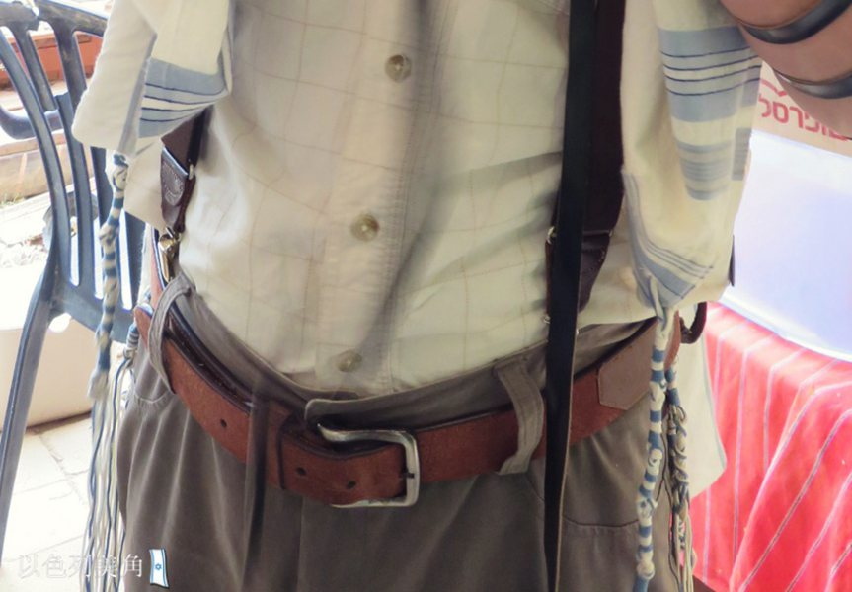

# 第 六日 读《民数记》15:1-41

# (a)请找出本章圣经提及同居的外人和犹太人同归一例的经文，写下这些经文的章节。

_______________________________________________________________________

_______________________________________________________________________

(b)你从这里了解到神的什么心意（请写下一句新约圣经同样启示的经文），并写下对你的鼓励和提醒。_______________________________________________________________________

_______________________________________________________________________

_______________________________________________________________________

_______________________________________________________________________

_______________________________________________________________________

_______________________________________________________________________

_______________________________________________________________________