 13: 1-33窥探应许之地
成人/青壮/长者
查经团契

《民数记》第十二课
日期：________________
2021

第一日 读《民数记》第十一课

请分享过去一周铲除心中嫉妒的操练。
_______________________________________________________________________
_______________________________________________________________________
_______________________________________________________________________
_______________________________________________________________________
_______________________________________________________________________

第 二、三 日 读《民数记》13：1-25； 《申命记》1:19-25；派出十二探子

请比较《民》13:1-3 与《申》1:22。差探子考察迦南地是出自百姓、摩西还是神？
_______________________________________________________________________
_______________________________________________________________________
_______________________________________________________________________
_______________________________________________________________________
_______________________________________________________________________

(a)探子们考察些什么，目的是什么？
_______________________________________________________________________
_______________________________________________________________________
_______________________________________________________________________
_______________________________________________________________________

(b) 你认为做这样的考察是明智之举吗？为什么？
_______________________________________________________________________
_______________________________________________________________________
_______________________________________________________________________
_______________________________________________________________________

你如何看待今天基督徒对所要拓展的事工是否应当做“考察”、应当如何做？_______________________________________________________________________
_______________________________________________________________________
_______________________________________________________________________
_______________________________________________________________________
_______________________________________________________________________

请在以下地图上找出探子所到之处。

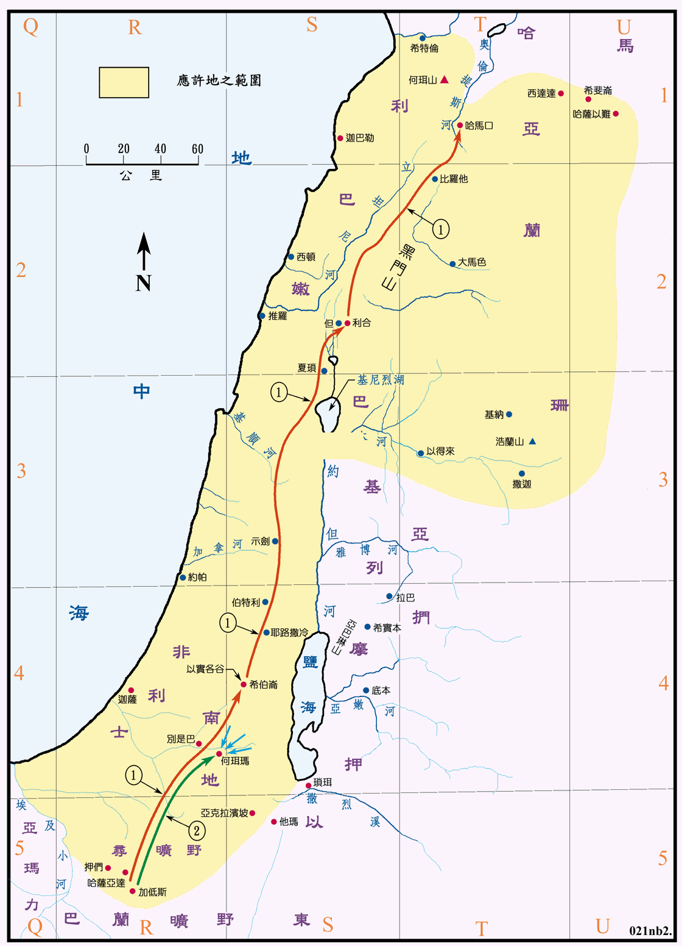

第 四、五、六日 读《民数记》13:26-33 探子的报告

(a) 十二探子用了多少时间来窥探那地？从第27-29节记载，那地如何？
_______________________________________________________________________
_______________________________________________________________________
_______________________________________________________________________
_______________________________________________________________________
_______________________________________________________________________

(b) 他们的报告符实吗？他们的报告上出了什么问题？
_______________________________________________________________________
_______________________________________________________________________
_______________________________________________________________________
_______________________________________________________________________
_______________________________________________________________________

(c)请反省自己是否也曾有类似的问题。请与弟兄姐妹分享你的学习。
_______________________________________________________________________
_______________________________________________________________________
_______________________________________________________________________
_______________________________________________________________________
_______________________________________________________________________
_______________________________________________________________________

迦勒如何激励你？请为自己做一个祷告。
_______________________________________________________________________
_______________________________________________________________________
_______________________________________________________________________
_______________________________________________________________________
_______________________________________________________________________
_______________________________________________________________________

